유봉희 EU BONG HEE

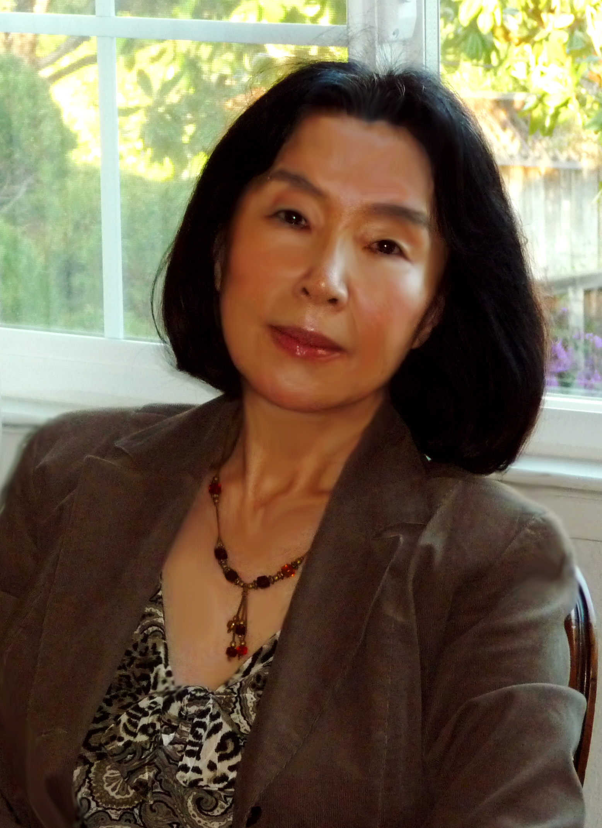

A native of Suweon, Eu moved to the States in 1972. She graduated from Ewha Woman’s University with a degree in Sociology. She debuted in 2002 in the magazine Literature and Creation (Munhak gwa changjak). Her poetry collections include Salt Fossils (Sogeum hwaseok) (2003), Tens of Thousands of Years of Steps (Myeot mannyeon eui geoleum) (2006), I Briefly Saw the Feet of Time (Jamggan sigan eui baleul boatta) (2012), and The World Passes By in Bare Feet (Sesang i maenballo jinaganda) (2017). She serves on the editorial board of Berkeley Literature (Beokeulli mnhak) and as Director of the American Literary Society (Miju munhyeop), In 2014, she was awarded the People’s Choice Award for Poets..

하늘의 창
저 멀리 높이 불 밝힌 창
내 전생에 지구 밖 허공에 불 켜 놓은 창
이생에 올 때 끄는 것 잊어버렸네
밤마다 몇백 광년 달려와서 나를 일깨우지만
내세에도 진즉 잊은 듯 끄지 않을 것이네

그늘을 밀어내다
서쪽 밤하늘에
잘 벼린 금빛 칼날
칼끝을 안으로 오므려
제 몸을 향하고 있다
한 뼘씩 자기의 그늘
다 밀어내면
끝내 칼끝 맞물려 잠그고
둥글게 금빛 차올리겠지만
오늘은 제 안에 그늘 무성한
초승달
A window in the sky

Far away and high above, a brightly shining window.
In my previous life, in the space beyond the earth, I lit up that window.
I forgot to turn it off when I came into this present life.
Every night, traveling through many hundred light years,
it reminds me of my neglectfulness.
I am not going to turn it off, even in my next life, keep pretending I forgot.

Carve away the shade

In the western night sky
Hangs a well- honed golden curved knife.
The tips of the blade bend inward
Pointing towards its own body.
After it carves away inch by inch
All of own shade
Finally both ends of the blade meet each other and interlock.
It will fill up the circle in golden light.
But tonight, there is plentiful shade
In the crescent moon.

정은숙 Jeong Eun-suk
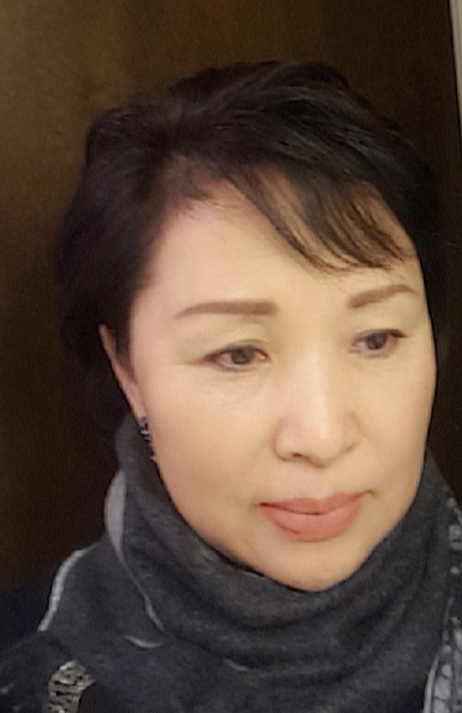

A native of Busan, Jeong moved to the U.S. in 1979. She debuted in 2001 in the literary magazine Munye Undong. In 2003, she published her collection “With the Translucence of Your Light”. (Dangsin eui bit geu tu’myeongham euro). She studied at the “Le Cordon Bleu” Culinary School at San Francisco and worked as Michelin a 3-Star BENU chef. She also operated the Korean Restaurant “SURA”.
Jeong is an editorial board member of the literary magazine Berkeley Literature (Beokeulli munhak) and serves as executive secretary of the Berkeley Literature Association.
유성流星

용한 점쟁이 만나 물어봐야겠다
머나먼 전생의 어느 별에서 우리 만난 적 있었는지

눈 들면
수백만 광년의 긴 세월 달려와 서러운 눈물로 가슴 한가운데
떨어져 내리는 당신에 대하여

만나야 할 때는
아득히 머나 먼 은하의 강 너머 손 닿을 수 없는 곳에 떠 있더니
등 돌리고 떠나야 할 때 수십만 킬로의 위험한 과속으로 어둡고 험한 길 달려와
찬 슬픔으로 가슴 한가운데 쏟아져 내리는 당신에 대하여

무슨 인연의 주술에 걸려 우리 이리도 쓸쓸한 길 가야 하는지
아무래도 용한 점쟁이 만나 물어봐야겠다

The Comet

I should ask a good fortune teller
if we met at some star in a past lifetime

and about you
who when I open my eyes
runs the stretch of a million light-years of time
to come showering down to the center of my heart
with tears of grief

about you
who when we need meet
hovers somewhere unreachable, beyond the stretch of the Milky Way --
then when I turn my back to leave,
runs millions of kilometers at breakneck ultra-speed a precipitous path
to come shooting down to the center of my heart
with your icy sorrow

I should ask a good fortune teller
what lonesome path we
caught in some karmic spell,
are predestined to go
창을 열면

깊은 밤
묵빛처럼 스미는 어둠을 깨고 창을 열면
긴 그림자 남기고 어두운 밤하늘 홀로 떠나는 너의 별

운명이라는 것에 무릎 끓고
무너져 내리는 너를 보는 것은 너무도 쓸쓸하다

이승을 떠돌아
찾아낸 너의 문은 굳게 닫혀 있고
살 속에 박힌 얼음 같은 적막이 무수한 별이 되어 쏟아져 내리는데

오래된 우리의 기억들은
이제 빛 잃은 행성이 되어 어둠에 떠있고
내 뼈로 만들어낸 투명한 사리 하나 네 영혼의 다비에 맑은 눈물로 남겨둔다

네가 떠난 자리 눈물 젖은 자리
숨막히게 붉디 붉은 비감의 빛으로 가슴에 차올라 너에게로 가는 발목을 묶고 있다

When I Open a Window

in deep night
when I open a window and break the darkness bleeding like india ink
your star departs alone for the murky night sky leaving a long shadow

seeing you fall to your knees and crash
at the thing called fate is simply too woeful to bear

your gate --that I found while wandering this world-- is tightly shut
and desolation like ice bedded in flesh becomes countless stars pouring down

our old memories
become planets fallen dark and hover in blackness
and with clean tears
I leave a transluscent sacred relic made of my bone at the cremation of your soul

at the spot where you were, that spot soaked with tears
the light of a crimson sorrow welling up like death in my breast
binds my ankles from going to you

*Translated by Professor Gabriel Sylvian

