AN EVENING OF KOREAN POETRY

Thursday Feb. 22nd 4:00 PM / Berkeley City Club
Sponsors: The Center for Korean Studies, UC Berkeley
Korean Literature Translation Institute

An Evening of Korean Poetry

Opening Remarks:
Laura Nelson (Chair, Center for Korean Studies, UC Berkeley)

Keynote speech:
Oh, Sae-young and Korean Modern Poetry
David McCann (Harvard University)

Poetry Reading:
Oh, Sae-young & David McCann
Lee, Jaemoo & Gabriel Sylvian
Jeong, Keutbyul & Clare You

Student Readings
Special Guest Reading

Closing;
Kwon, Youngmin (UC Berkeley)

Oh, Sae-young

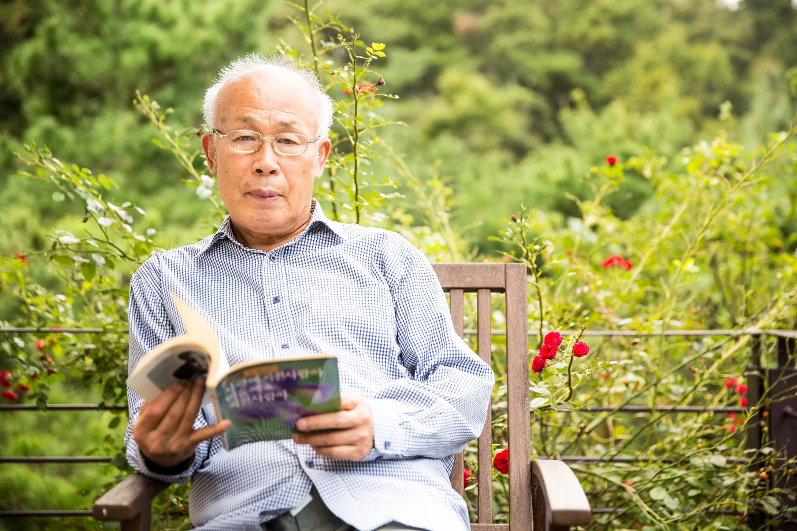

Born on May 2, 1942 in Yeonggwang, South Jeolla Province, Oh entered the department of Korean literature at Seoul National University, where he received his PhD in 1980 and taught Korean Poetry from 1985 to 2005. Now he is an Emeritus Professor of Seoul National University and a member of Korea National Academy of Arts .
Oh, Sae-young made his literary debut in the mid-1960s. For a time, the poet Oh devoted his writings to the pursuit of subconscious fantasies, but he gradually changed his work to represent a lyrical quest for vitality. Beginning with the linked-poem “Unenlightened Love Poems” (Mumyeong-yeonsi) and other pieces such as “The Soil of Contradiction” (Mosun-ui heuk), “Selected Melancholy Poems” (Ususicho), “Bowl” (Geureut; another linked-poem work), “Acrobat” (Akeurobateu) and “A Summer Day” (Ha-il), he demonstrates a consciousness of history developed through an awareness of the shaping forces of human identity and being. He also expresses traditional sentiments through self-conscious language influenced by modernism. His work is characterized by a fusion of lyricism and intellectualism, which works to control his language and produce poems of extreme refinement and condensation.
Today, Oh Sae-young is described as a poet who has lyrical sense, philosophical intellect, and sophisticated linguistic awareness. His writing bores into the double-sidedness and hypocrisy of existence. His major work, Sae (새 The Bird), depicts birds that soar into the sky toward the truth and freedom, but ultimately must fall, showing humanity’s fateful burden. The poem’s structure demonstrates that as its imagery flies higher, the distance back to the ground grows further, illustrating the insight that though humans strive endlessly for the ideal, they are ultimately fatalistic beings that must return to the ground.
The Chicago Review of Books has said that “Sae-young’s attention to detail, and his ability to shift back and forth between scopes both grand and minuscule, provide a sense that his poems are inextricably linked to something larger.” The reviewers note that his poetry collections contain “work very much obsessed with existence, the building and destruction of nature, business, war, and industry. He unexpectedly examines merit, plays with worth, while lingering on the edge of past and present.”
Oh, Sae-young has published 24 volumes of his poetry collections. Among his best-known poetry collections are Light in Revolt (1970), The Darkest Evening (1982), Love Song of Unenlightened Longing (1986), Burning Water (1988), A Shadow of Sky in Tears (1994), A Boat of Time (2005), Calling of You, Sound of Waves (2008), A Shadow of Wind (2009), Sons of Wind (2014). His research studies and collections of criticism include A Study of Korean Romantic Poetry (1980), Directions in Contemporary Korean Poetry (1988), Imagination and Logic (1991) and A Study of Twentieth-century Korean Poetry (1999).
His poetry has been translated into several languages, including English: Flowers Long for Stars (2005), Night-Sky Checkerboard (2016), in French; Songe de la falaise (2012), and in German; Das ferne Du, (1999), Gedichte jenseits der Liebe (2000), and in Spanish; Más Aallá del Amor (2003).

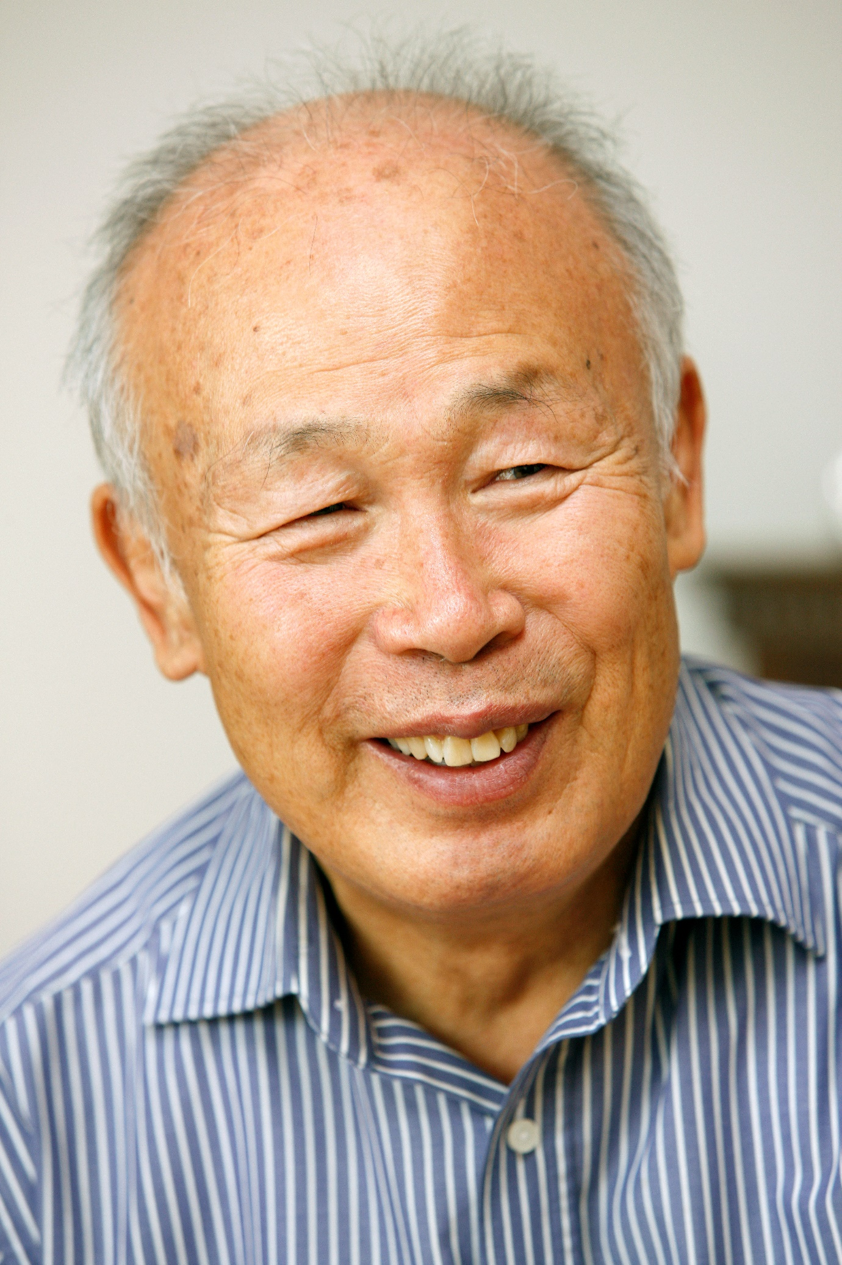
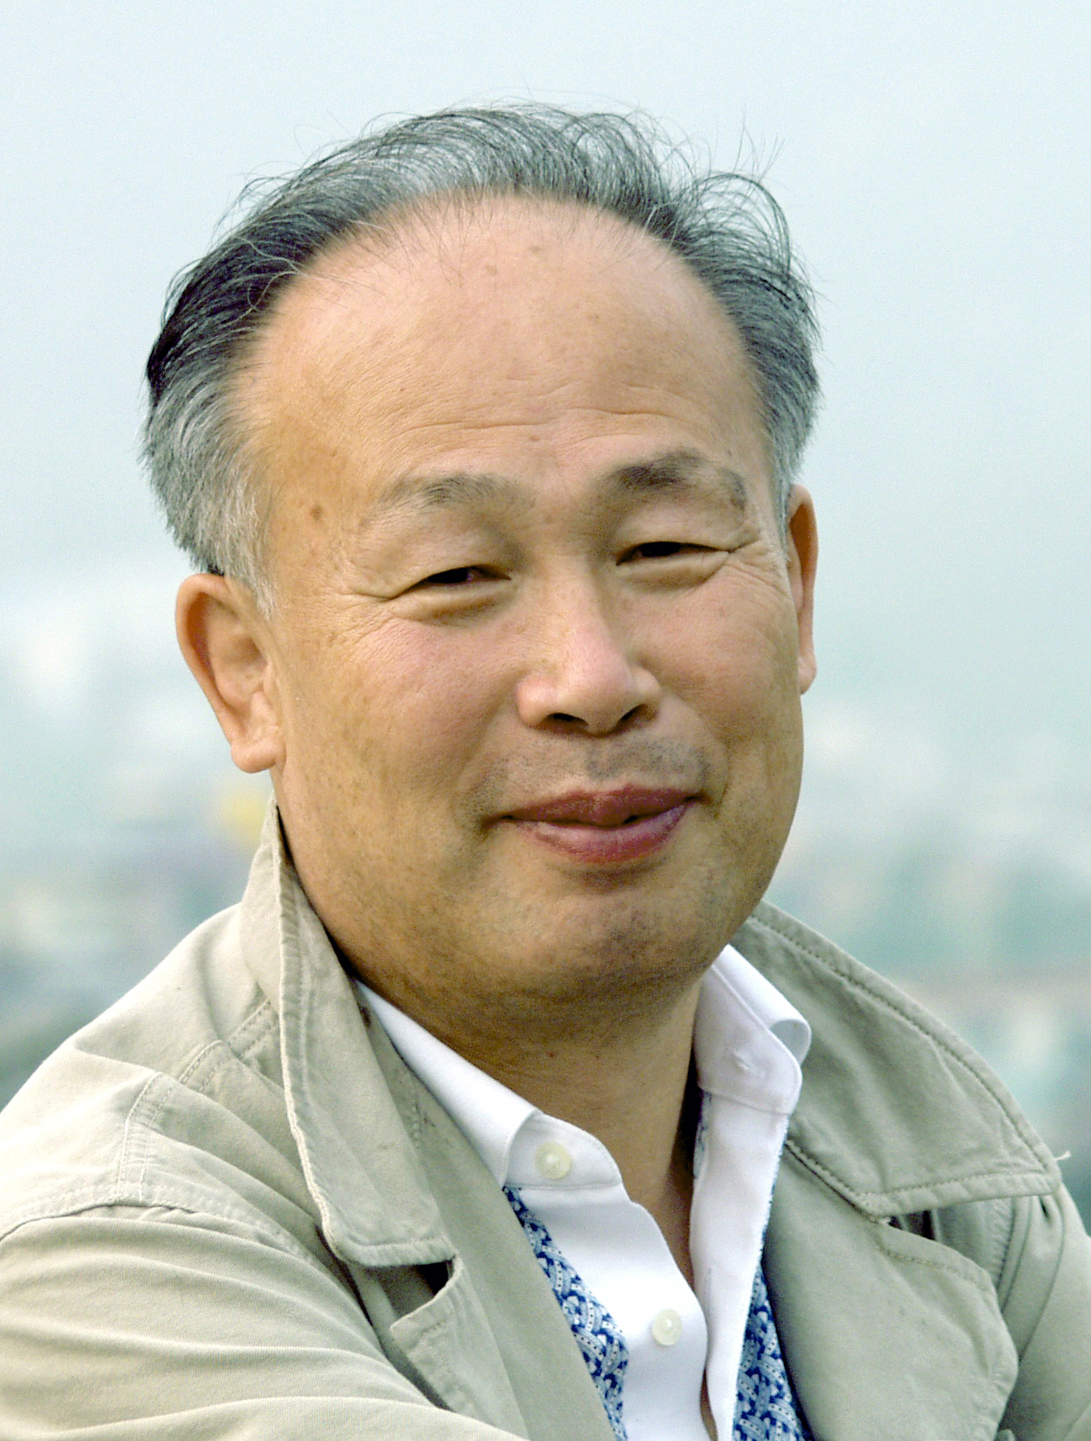

My poetry
Oh Sae-young (poet, professor emeritus at Seoul National University, member of Korea National Academy of Arts)

I would like to take this opportunity to reflect back on my writing habits and attitude toward poetry.
Living with poetry: As everyone knows, I am both a professor and a poet. I cannot neglect either of those responsibilities and have been faithful to both partly because of my perfectionism. However, frankly, I was never able to devote myself wholly to writing poetry since I always had to spend half my time studying. I think that I actually devoted more time to my research than to writing poetry, so you could say that the literary circle only sees one half of me.
Everyone wants to succeed in life, and success is achieved through efforts. I myself worked hard to reach this dual goal. But success is a rare prize. I lack in many areas, so the only way I have a chance at succeeding is by using my time very wisely. Still, there is only so much you can do to save time—not meeting people, avoiding get-togethers, and not drinking. This is the reason why I have never held any higher position, not even a department chair, and why I don’t have many close friends in the literary circle despite having worked for thirty years as a professor, though that could be due to my personality. In that regard, the fact that I am a professor at a so-called prestigious university is not helpful for my poetry.
Time spent on writing poetry: Many part-time poets would agree, but going from living one’s daily life to being a poet is not easy. Maybe this is truer in my case because I am a research professor. Research is based on rationality and logic, whereas writing poetry is done through one’s feelings and intuition. The two fundamentally conflict with each other. Generally speaking, the right-brain is in charge of rational thinking that is activated when studying, and the left-brain is connected to emotional activities such as writing poetry. Therefore, suddenly shifting from using the right-brain at one’s workplace, doing intellectually challenging work such as writing papers and teaching, to using the left brain is a difficult task unless you are a robot. I had to experiment in order to figure out how to overcome this challenge throughout my long literary career. What I learned is as follows:
The first tip is to leave a consistent time gap between living your daily life and writing poetry. Stop all brain activity and do not engage in any intellectual activities in order to let time pass by idly. Spend two to three days staring at the television, mindlessly listening to music, traveling by yourself to a faraway place, or even binge drinking occasionally. If you have a special someone, hanging out with that person will probably help greatly as well. A poet should be able to work and play at the same time, and a poem is something you write as you play. One of the things I do for fun is spending a winter at a mountain temple, which became a routine as I got older. I particularly enjoyed staying at Samhwa Temple on Mt. Doota, Gooryong Temple on Mt. Chiak, Mihwang Temple on Mt. Dalma, Baekdam Temple on Mt. Seorak, and Hwaam Temple on Mt. Geumgang. I actually just returned home a couple days ago from a twenty-day stay in the Manhae Village at Baekdam Temple.
Writing poetry: Some poets can’t write without an inspiration, meaning they can’t write whenever they want. But I am a little different. Once I transition away from living my daily life and put on my poet hat, I can start writing whenever I want. As this transition from the realm of daily life to that of poetry is voluntary and does not happen mysteriously by chance, the act of “writing poetry whenever I want” is also led by my intention and choice. I am a person who can produce a poem whenever I want if I make up my mind. Whether that poem is good or bad is a completely different matter. If you think about it, not all inspired poets produce good poems either.
Poets are not special people. Anyone who writes poems, regardless of their quality, is a poet. Nevertheless, the reason why we generally label as poets those who have passed the special institution called “debut” is because we consider debuted poets as professionals, not amateurs. In other words, making a debut as a poet is like being officially recognized that you are no longer an amateur, but a professional writer. The difference is not in how well the person writes, but in the ability of that individual to produce a piece of art. If we merely cared about the quality of poems, then there would be many cases of amateur poets creating superior poems to those of debuted professionals.
Professionals should be experts in their respective fields. Professional athletes don’t just refuse to play because they feel like it. Writing poetry is the same. A true poet has to be able to immediately produce a poem as necessary or upon receiving orders such as a manuscript request. If this is impossible to do, then a poet must doubt one’s own ability rather than blame it on the absence of inspiration.
Poetry and idea: Obtaining a poetic idea is comparable to a “seon (선, 禪, Zen)” experience. I do not mean to say that they are the same; the ultimate goal of “seon” is to go beyond making a value judgment about an object and to enter the realm of complete freedom or nothingness, while poetry returns to an object’s true meaning in the end. Poetry and “seon” are only alike in that both initially deny and dismiss an object as nothing. Likewise, my poetry writing is a process that starts with a quiet meditation about an object. The process helps empty this world and my self and enlightens me at a certain critical moment. Once I gain an enlightenment, I simply have to turn it into an aesthetic image. Therefore, the enlightenment itself is what makes up a poem. This is another similarity between poetry and “seon.” Fortunately, I have a secret formula for creating an aesthetic image that I mastered through decades of writing, so I do not have a problem there.
However, in order to obtain a poetic idea through meditation, being in the right physical environment is extremely important. You first need time and space to focus your mind on one thing. This is why I usually write poetry at night in a closed space. If I cannot avoid writing during the day, I close the windows and curtains even in summer heat and turn on a lamplight instead. After a couple hours of deep meditation in darkness with my eyes closed, I can always write at least one piece of poetry. This method has never failed me.
There’s one more thing I’d like to add. It is that I have never treated writing poetry as a joke. Regardless of when and what I write, I have always put in my best efforts to create a piece of art. Such attitude is probably reflected in my habit of never throwing away manuscripts or waste papers with my poems on them. Instead, I light the papers on fire and let the ashes fly away. No wonder why my poems written with such careful attitude receive reviews saying they are too serious and rigid. But I do not yet wish to change my way of writing.
My idea of poetry: Many people actually question whether poetry is considered an art. They question because poetry differs from other forms of art such as visual arts or music in many fundamental ways. The first difference is medium. Everyone knows that the mediums for music and visual arts are hearing and vision, respectively, whereas poetry uses language. But many fail to recognize that hearing and vision are bodily senses when language is only a system of symbols. For instance, in a painting, the color red is perceived as the color red through our vision, but the word “red” in a poem is not actually red. The word “red” is only an agreement between people that the word should be understood as the color red. Language is conceptual and symbolic, which is why literature may not seem like an art when compared to music or visual arts.
Yet, no one can deny that literature, hence poetry, is part of art. It is just that literature is a different form of art than visual arts or music. In aesthetics, art forms such as literature that use symbols (i.e. language) as their medium is considered conceptual art, and other art forms such as visual arts and music that are perceived through human senses are called material art. This divide represents the fate of literature, or poetry; by fate, poetry is an art that is much more significant than just its aesthetics. Unlike the sensory mediums of other forms of art, language is a system of symbols that hold meanings, and these meanings lead to ideas and philosophy. Therefore, a good poem can only be written when a poet transcends the realm of aesthetics and enters into the world of philosophy.
For a while, a type of poetry movement called “no-meaning,” which sought to liberate poetry from meaning was in fashion in Korea. But no matter how hard one tries, it is difficult to make a great poem that way since a poem without any meaning could hardly transcend the realm of aesthetics and surpass visual arts or music. One only ends up damaging the status of poetry. Thus, all great poems must be created through a convergence of aesthetics and philosophy.
Poetry and truth: There are many poems that are difficult to comprehend. People say that poetry is difficult. This is true to some degree, as poetic language is different from our spoken language and naturally contains some abstruse elements. Scholars who study poetry even divide this abstruseness into categories: ambiguity (unavoidable abstruseness caused by language), obscurity (abstruseness originating from ontological conditions), and vagueness (complexity caused by falsehood). Nevertheless, poetry should be written as easy as possible. Unfortunately, abstruse poems are trending in Korea, and people seem to think that poems ought to be abstruse despite the fact that a poem that is incomprehensible to even cultured intellectuals is problematic. There are more poems out there than you think that intentionally twist their otherwise easy content, and they do it in a way that’s rather obvious to readers. Only those with selfish ulterior motives would write unnecessarily difficult poems.
In my opinion, there are four types of poetry: 1) easy poetry with easy content, 2) difficult poetry with easy content, 3) difficult poetry with difficult content, and 4) easy poetry with difficult content. The first type of poetry is closer to prose and remains in an elementary stage. The second type is written by poets who either lack ability or are trying to trick others. Poets of the third type are writing about something that they don’t quite understand themselves and, thus, are passionate fools. Authors of the fourth type are poets whose understanding of poetry has matured. If one were to rank the different types, it would be in the following order: 1) the fourth, 2) the first, 3) the second, and 4) the third. Poetry that explains difficult content in an easy way is considered most superior.
Attitude toward poetry: To some people, poetry is their life. And there are also those who argue or believe that poetry is the only noble value in human life. They say that there is no reason to live without poetry. But I do not agree with them. Life isn’t only about poetry nor is poetry our noblest pursuit. Poetry is simply one component of our lives and one of the many values that people seek. Consequently, communities may choose to abandon poetry depending on the circumstances and times. I can also do the same if there is a special need.
Insisting on writing poetry when one’s loved ones are starving and suffering poverty is not right. At such times, one should prioritize earning money to feed the family over poetry. If our national and human rights are at risk and our dignity is being threatened, we ought to put away poetry and fight. But poetry may be the only means of resistance for some people, and they should rightfully use poetry as a weapon to battle against reality—not because fighting is the essence of literature, but because turning poetry into a political weapon and not just seeing it as a pure form of art is sometimes more appropriate in light of greater human values.
Therefore, I detest those who only devote themselves to poetry day and night and say that there is no life without poetry. I also do not approve of people who claim that poetry is the mankind’s noblest pursuit and those who think highly of themselves because they are poets. I can confidently say that the reason why great poets are great is because they have written great poems. Being a poet alone does not make a person great. So do not go out of your way to become a poet. Do not expect to be treated better because you write poetry. There are numerous higher and more valuable pursuits in this world. Poetry is simply destined for those whose passion and talent for poetry make them unable to pursue anything else in life.
Footsteps in Snow

Who asked me to write this?
Turning into a dreaming ballpen, on the snowy ground
neatly
I inscribe one lyric line, then make my way down.
A magpie,
dozing perched at the tip of a poplar branch,
abruptly
opens its eyes at the sound of a snow-laden branch breaking.
Caw-caw,
it is reciting in a resonant voice—
on

눈 발자국

누가 시킨 운필인가.
나 한 개 꿈꾸는 볼펜이 되어 눈밭에
또박또박
서정시 한 행을 써 내려 간다.

미루나무 가지 끝에 앉아 졸고 있다가
문득
설해목(雪害木) 부러지는 소리에 눈을 뜬
까치 한 마리,
까악까악
낭랑한 목소리로 읊고 있다.
그 시 한 구절.

Vapor Trail

The thunder and lightning accompanying the thunderstorm
at midday
seem to have torn one edge of the sky,
the oxygen in the air is leaking away;
a jet plane
scrambles, comes flying fast
and carefully mends the cloth
with rapid lockstitch.
As it heads into the twilight,
the white seam is clearly visible—
a long
vaportrail

비행운(飛行雲)

한낮
뇌우(雷雨)를 동반한 천둥번개로
하늘 한 모서리가 조금
찢어진 모양,
대기 중 산소가 샐라
제트기 한 대가 긴급발진
천을 덧 대 바늘로 정교히
박음질 한다.

노을에 비껴
하얀 실밥이 더 선명해 보이는
한줄기 긴
비행운(飛行雲).

The Cloud

The cloud
is a cloth rubbing at heaven’s windows;
if you squeeze it,
water runs out.
Breathing, puff,
then rubbing, rubbing away
before peeping out again, old God’s
prying eyes.

구름

구름은
하늘 유리창을 닦는 걸레,
쥐어짜면 주르르
물이 흐른다.

입김으로 훅 불어
지우고 보고, 지우고
다시 들여다보는 늙은 신의
호기심어린 눈빛

A Bowl

A broken bowl
becomes a blade.
When might goes astray
amidst moderation and balance,
broken circles
make a sharp edge
and force open reason's
ice-cold eyes.
Ah, potsherd aimed
at unseeing love,
I am barefoot now.
I am flesh
waiting to be slashed.
A soul maturing since the wound is deep.
A broken bowl
becomes a blade.
Any broken thing
becomes a blade

그릇

깨진 그릇은
칼날이 된다.

절제와 균형의 중심에서
빗나간 힘,
부서진 원은 모를 세우고
이성의 차가운
눈을 뜨게 한다.

맹목(盲目)의 사랑을 노리는
사금파리여,
지금 나는 맨발이다.
베어지기를 기다리는
살이다.
상처 깊숙히서 성숙하는 혼(魂)

깨진 그릇은
칼날이 된다.
무엇이나 깨진 것은
칼이 된다.

Music

When their leaves have fallen
the winter trees
turn into musical instruments,
instruments
ringing out at the wind's fingertips
following the notes hanging in the sky.
And not only trees.
Listen to the streams in the valleys.
Water bouncing off rocks as it flows
echoing under sheets of ice
is music too.
The tree where high notes ring from high branches
low notes from low branches
is a stringed instrument,
the valley where loud notes ring from big rocks
quiet notes from small rocks
is a wind instrument,
On a day like today
when snow has fallen white over the world,
the image of the one we yearn for effaced,
I want to listen to music
leaning here beside my window.
Emotions come through the ear
rather than the eye,
winter is a rainbow emerging through hearing

음악

잎이 지면
겨울 나무들은 이내
악기가 된다.
하늘에 걸린 음표에 맞춰
바람의 손끝에서 우는
악기,

나무만은 아니다.
계곡의 물소리를 들어보아라.
얼음장 밑으로 공명하면서
바위에 부딫혀 흐르는 물도
음악이다.

윗가지에서는 고음이,
아랫가지에서는 저음이 울리는 나무는
현악기,
큰 바위에서는 강음이
작은 바위에서는 약음이 울리는 계곡은
관악기.

오늘처럼
천지에 흰 눈이 하얗게 내려
그리운 이의 모습이 지워진 날은
창가에 기대어 음악을
듣자.

감동은 눈으로 오기보다
귀로 오는 것,
겨울은 청각으로 떠오르는 무지개다.

Fruit

I wonder why all the fruit in the world
have to be round.
On the spiny branches of the thorny orange
the scented fruit alone are round.
The roots delving down down into the ground
are sharp,
the branches stretching up up into the sky
are pointed,
but the fruit, quite able to ripen and drop for themselves,
show no signs of any angles.
A single crab-apple
that can be bitten and devoured in a single
munch
the teeth of the eater may be sharp
the crab-apple being eaten is soft.
Did you ever realize that
everything that is coming into being is round?
that fruit, knowing they are going to be eaten,
never develop angles?

열매

세상의 열매들은 왜 모두
둥글어야 하는가.
가시나무도 향기로운 그의 탱자만은 둥글다.

땅으로 땅으로 파고드는 뿌리는
날카롭지만,
하늘로 하늘로 뻗어가는 가지는
뾰족하지만
스스로 익어 떨어질 줄 아는 열매는
모가 나지 않는다.

덥썩
한입에 물어 깨무는
탐스런 한 알의 능금
먹는 자의 이빨은 예리하지만
먹히는 능금은 부드럽다.

그대는 아는가,
모든 생성하는 존재는 둥글다는 것을
스스로 먹힐 줄 아는 열매는
모가 나지 않는다는 것을.

Far-sightedness

Far-off things
are beautiful.
Rainbows, stars, or flowers blooming on cliffs,
far-off things,
are beautiful
because they can't be touched.
You who love me,
do not grieve over parting
for parting at my age is
not separation but merely
a simple matter of moving farther off.
The age at which I need glasses
now
in order to read your last letter,
growing old,
is something
that sends the one I love farther away.
It's a matter of knowing
how to see from far away.

원시(遠視)

멀리 있는 것은
아름답다.
무지개나 별이나 벼랑에 피는 꽃이나
멀리 있는 것은
손에 닿을 수 없는 까닭에
아름답다.
사랑하는 사람아,
이별을 서러워하지 마라,
내 나이의 이별이란
헤어지는 일이 아니라 단지
멀어지는 일일 뿐이다.
네가 보낸 마지막 편지를 읽기 위해선
이제
돋보기가 필요한 나이,
늙는다는 것은
사랑하는 사람을 멀리 보낸다는
것이다.
머얼리서 바라다볼 줄을
안다는 것이다.

*Translated by Brother Anthony
Lee, Jaemoo

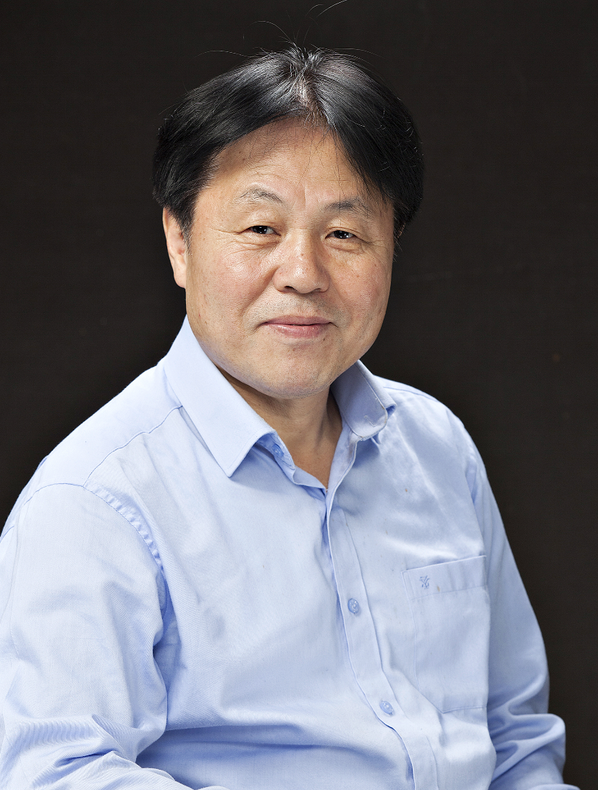

Lee, JaeMoo was born in Buyeo, Chungcheongnam-do, South Korea. He graduated from elementary school and middle school in his hometown of Buyeo and finished high school and college in Daejeon. He completed his master's degree in Korean Language at Dongguk University in Seoul.
In 1983, he began his literary activities by publishing four poems, "Pick one’s ears" in "Literature of Life". For many years, he lectured on book production in publishing companies and taught Korean language classes at college preparatory academies. He also gave creative poetry lectures at various universities. Currently, he is the director of the literary group for the Korean Writers Association and the representative director of the publishing company, Start of the Millennium. Over the last 35 years, he has published many volumes of collected poetry, including the following: “New Year's Eve“ “Do Not Come to the People“ “Mow the Grass“ “Flowers in the Body“ “Great Meal“ “The Net of Time“ “Blue stubborn“ “Evening 6“ “A Cheerful Wandering“ “Sadness Kneeling“ “Sadness Pours on the Shoulders“ “An Anthology of Poetry“ “Old Jokes“ “Meals on the Way“ “Essay book“ “From the Front of the Living“ “The Tastiest Rice in the World“ “Fleeing from Obsession“ “Comments on Current Literature“ and “When the Flower Blooms Among People“.
Lee’s awards include the Sowall Literary Award, Yoon Dongju Literary Award, Nanko Literary Award, Phyunwoon Literary Award, Pulkyot Literary Award, and Song Sukwon Literary Award.

My life, my literature
Lee Jaemoo (poet)

My literary career began in the 1980s. Just as all people are influenced by the paradigm of the times they live in, I have also been influenced by the paradigm of the 80s for a long time. Of course, I have come far since then both physically and psychologically, but my mind is still not completely free from that time. As everyone knows, the 80s was an era of meta-narratives. It was an era in which the focus of literature was unevenly concentrated and shifted to one side. During those times, we liked to discuss themes and subject matters that were heavy, and the mainstream literary discourses then were class, nation, the mass, and reunification. However, as socialist groups fell one by one in the early 1990s, people grew more skeptical about the meta-narratives, and many micro-narratives trying to overcome the skepticisms emerged in competition. For instance, new postmodernist discourse replaced the modern enlightenment discourse in the West, and movements such as modernism, feminism, ecologism, post-historism, and eco-feminism rose in efforts to transcend and overcome modernism.
Poetry was also part of this flow of changes. In place of labor poetry, reunification poetry, peasant poetry, and experimental avant-garde poetry came poetry focusing on urban, ecological, feminist, daily, spiritual, and “seon” subjects.
As a man shaped in the 80s, I once had a prideful, grandiose dream as well. I strongly believed that poetry could lead social changes and thought that those who shared this belief must attempt to fix the world by resolving social, political, and economic structural contradictions. In addition, a poet should actively participate in such movement as a member of society. These were my stubborn thoughts. In a way, the grim reality of the era was to blame for burdening emotionally sensitive poets with a sense of duty—how could a proper citizen with a basic moral sense turn a blind eye to the crazy and barbaric reality of the time? In those times, members of literary circles could not help but be at the forefront of social changes. I also supported and participated in the movement as much as I could, but society did not change the way we hoped.
I no longer think that literature should be a weapon for social change. That would be impossible to do, and it would be anachronistic to keep thinking that way. Moreover, I’m not a blind supporter of enlightenment who insists that literature should be used as a tool for social change as it once was. But that doesn’t mean that literature should exist exclusively for the enjoyment of a few.
Korea today is too divided. The national division and tensions due to the long-standing hostility and confrontation between North and South Korea have led to increasing tensions within South Korea. Such tensions and division have become so internalized within individuals that they have become numb. There are tensions between regions, between capital and labor, between ideologies, between genders, and between generations. In addition, new tensions are rising between the regions of Gangnam and Gangbook, adding onto the already complex situation. Even a membership in a literary circle cannot shelter one from the divided world of factions. I do not mean to say that all tensions are bad because sometimes they become a source of new energy and engines for life. The problem is that, as poet Ko Un once pointed out, we have developed a callous attitude toward tensions. A society cannot be productive when tensions, not vitality, persist.
Thus, what I would like to ask of other poets is to face the unproductive reality stricken with tensions and divisions rather than ignore it. Taking an interest and expressing one’s concerns is the first step to overcoming social discord, mistrust, and lack of communication. Literature and poetry should play a role, and they should do so in new and innovative ways.
As a poet, this is the world I hope to see: a world equipped with a basic safety net for everyone; a world where the marginalized can freely discuss their hardships and cry out for help; a world that is not dog-eat-dog but one where nations seek for ways to coexist peacefully; a world without class, generation, regional, and gender gaps; a world that is not divided over ideologies; a world without discrimination; a world where no parents or young people feel pressured to end it all when they feel they have failed in life; a world that is not in a war of all against all; a world that does not celebrate winners only; a world where the cost of raising a child doesn’t discourage couples from getting married; a world that provides people with a work-life balance so that they can fully enjoy their “evening life,” as one politician put it; and a world where people do not worry about jobs and retirement. My list goes on.
But how can poetry possibly help us create such a world? I’m not saying that poets have to take up the responsibility. I’m just saying that poets should at least express interest in these matters through their poems. In his essay collection, Poetry, Spit, poet Kim Soo-young writes that “a voice soft as that of a mosquito can pierce the 38th parallel.” The poet tells us that it is too early to give up and that we can overcome the national division if we gather all of our soft mosquito-like voices. Many people study Kim Soo-young’s poems and prose, but they rarely live out his messages. Having said so much, I feel that I am hopelessly lagging behind the times. I am still lost in the sweet dreams of enlightenment.
The Persimmon Tree

This persimmon tree wants some news:
That's why I stretch my branches toward the twig gate
and dangle red teardrops in the fall
that I wobble slightly in the wind.
The owner who put me in the earth
lived here for thirty years
but took a train and left me flat
fifteen years ago...
This persimmon tree is anxious for some word
That's why in the spring
I stick my new shoots out over the fence

감나무

감나무 저도 소식이 궁금한 것이다

그러기에 사립 쪽으로는 가지도 더 뻗고

가을이면 그렁그렁 매달아놓은

붉은 눈물

바람결에 슬쩍 흔들려도 보는 것이다

저를 이곳에 뿌리박게 해놓고

주인은 삼십년을 살다가

도망 기차를 탄 것이

그새 십오 년인데…

감나무 저도 안부가 그리운 것이다

그러기에 봄이면 새순도

담장 너머 쪽부터 내밀어 틔워보는 것이다

To Be in Ma-ryang

Wish I could take a girl, a secret flame,
to a distant seacoast town hardly on the map
and set up house with her for a season.
I'd know every inch of Ma'ryang village like my sister's hand mirror
after a few hours' walk.
Lying idly in the sleeping room of the tavern of time
crooning oldies and tapping my toes,
the woman, like a tidal flat,
will please my ears with her dialect,
and tickle my sides to her heart's content.
And why should I care what people think?
At morning tide I'd go out to the dock,
thrust myself in the water like a fishing pole
and pickle the wilted cabbage of my life in the jade-colored sea.
Then, grown tired of the pickling,
I'd take a motor boat and zoom off to far-flung seas.
Then bam, I'd come dangling my purse of secrets from my belt
and sit pretending nothing had happened,
uttering silly snickers whose meaning only I would know,
and let the rest of my fool life go to pot.

좋겠다, 마량에 가면

몰래 숨겨놓은 여인 데불고

소문조차 아득한 먼 포구에 가서

한 석 달 소꿉장난 같은 살림이나 살다 왔으면

한나절만 돌아도 동네 안팎

구구절절 훤한, 누이의 손거울 같은 마을

마량에 와서 빈둥빈둥 세월의 봉놋방에 누워

발가락장단에 철 지난 유행가나 부르며

사투리가 구수한, 갯벌 같은 여자와

옆구리에 간지럼이나 실컷 태우다 왔으면.

사람들의 눈총이야 내 알 바 아니고

조석으로 부두에 나가

낚싯대는 시늉으로 던져두고

옥빛 바다에 시든 배추 같은 삶을 절이고

절이다가 그것도 그만 신물이 나면

통통배 얻어 타고 휭, 먼 바다 돌고 왔으면,

감쪽같이 비밀 주머니 하나 꿰차고 와서

시치미 뚝 떼고 앉아

남은 뜻도 모르는 웃음 실실 흘리며

알량한 여생 거덜 냈으면,

Wonderful Meals

Those late evenings
as shadows on the mountain grew thick,
with the dirt-covered tools scattered carelessly in the shed,
a fire smouldering in the yard to choke mosquitoes,
my family, at a round table set on the straw mat,
would make silent, busy work with chopsticks and spoons
into the hot stew of bean paste and snails
like the fearless, leaping cries of night birds,
into the watery pickles
like a few stars floating like bits of pork fat,
into the bowls of cold water
like the springing chirps of yard bugs...
then, leaving out the twig gate,
relieving with burps my belly puffed out like a ridge line
from the pungent, unknowable sorrow of chomped green peppers,
the breathless pants of the moon staggering by Taeji Peak
heady with farmer's wine-
Ah, the wonderful meals back then!

위대한 식사

산그늘 두꺼워지고 흙 묻은 연장들
허청에 함부로 널브러지고
마당가 매캐한 모깃불 피어오르는
다 늦은 저녁 멍석 위 둥근 밥상
식구들 말없는, 분주한 수저질
뜨거운 우렁된장 속으로 겁없이
뛰어드는 밤새 울음,
물김치 속으로 비계처럼 둥둥
별 몇 점 떠있고 냉수 사발 속으로
아, 새까맣게 몰려오는 풀벌레 울음
베어문 풋고추의 독한,
까닭 모를 설움으로
능선처럼 불룩해진 배
트림 몇 번으로 꺼뜨리며 사립 나서면
태지봉 옆구리를 헉헉,
숨이 가쁜 듯 비들대는
농주에 취한 달의 거친 숨소리
아, 그날의 위대했던 반찬들이여

Jebu Island

The best distance to keep with a lover?
Think of Daebu Island and Jebu Island bridged one time a day
at low tide.
You should see your lover before you,
within your reach but really not.
The best depth to keep with a lover?
Think of Jebu Island and Daebu Island separated one time a day
at high tide.

Love should churn and brim at the high tide of longing,
then blossom to reveal a road to reunion at tide's ebb.
What of hellos and goodbyes?
Think two times a day.

Don't get too bothered, too hurt,
lest your disappointments and your happinesses
be at the proud whim of the other.

제부도

사랑하는 사람과의 거리 말인가
대부도와 제부도 사이
그 거리만큼이면 되지 않겠나

손 뻗으면 닿을 듯, 닿지는 않고,
눈에 삼삼한

사랑하는 사람과의 깊이 말인가
제부도와 대부도 사이
가득 채운 바다의 깊이만큼이면 되지 않겠나

그리움 만조로 가득 출렁거리는,
간조 뒤에 오는 상봉의 길 개화처럼 열리는

사랑하는 사람과의 만남 말인가 이별 말인가
하루에 두 번이면 되지 않겠나

아주 섭섭지는 않게 아주 물리지는 않게
자주 서럽고 자주 기쁜 것
그것은 사랑하는 이의 자랑스러운 변덕이라네

The Walking Lakes

The cow's big eyes are like lakes
Lakes brimming with tears.
Lifted up to the mountain before them
the mountain slides into the lakes.
Lifted up to the sky,
the clouds slide in, too.
When they blink,
the mountain slides out again.
The cow's eyes are slowly walking lakes.

걸어 다니는 호수

소의 커다란 눈은 호수 같다

그렁그렁 눈물이 고여 있는 호수

소가 눈 들어 앞산을 바라보니

앞산이 호수에 잠긴다

눈 들어 하늘을 바라보니

구름이 잠긴다

소가 꿈벅, 하고 눈을 감았다 뜨니

산이 눈을 빠져나오고

소가 또 꿈벅, 하고 눈을 감았다 뜨니

구름이 빠져 나온다

소는 느리게 걸어 다니는 호수를 가지고 있다

Hunting

Now into my forgetful years,
I hunt.
I hunt through pages of a book I've already read,
I hunt around for things I've lost,
I hunt through the closet for better things to wear.
I see the wind hunting around the grass,
the sunshine hunting around the leaves,
and the moonlight hunting around the river.
I secretly hunt in my mind for past loves.
Hunting means I've inscribed you deep within me.
Many hunting for yesterday
end up weeping today.
The birds hunt as they fly though the air.

뒤적이다

망각에 익숙해진 나이
뒤적이는 일이 자주 생긴다
책을 읽어가다가 지나온 페이지를 뒤적이고
잃어버린 물건 때문에
거듭 동선을 뒤적이고
외출복이 마땅치 않아 옷장을 뒤적인다
바람이 풀잎을 뒤적이는 것을 보다가
햇살이 이파리를 뒤적이는 것을 보다가
달빛이 강물을 뒤적이는 것을 보다가
지난 사랑을 몰래 뒤적이기도 한다
뒤적인다는 것은
내 안에 너를 깊이 새겼다는 것
어제를 뒤적이는 일이 많은 자는
오늘 울고 있는 사람이다
새가 공중을 뒤적이며 날고 있다

*Translated by Gabriel Sylvian

Jeong, Keutbyul

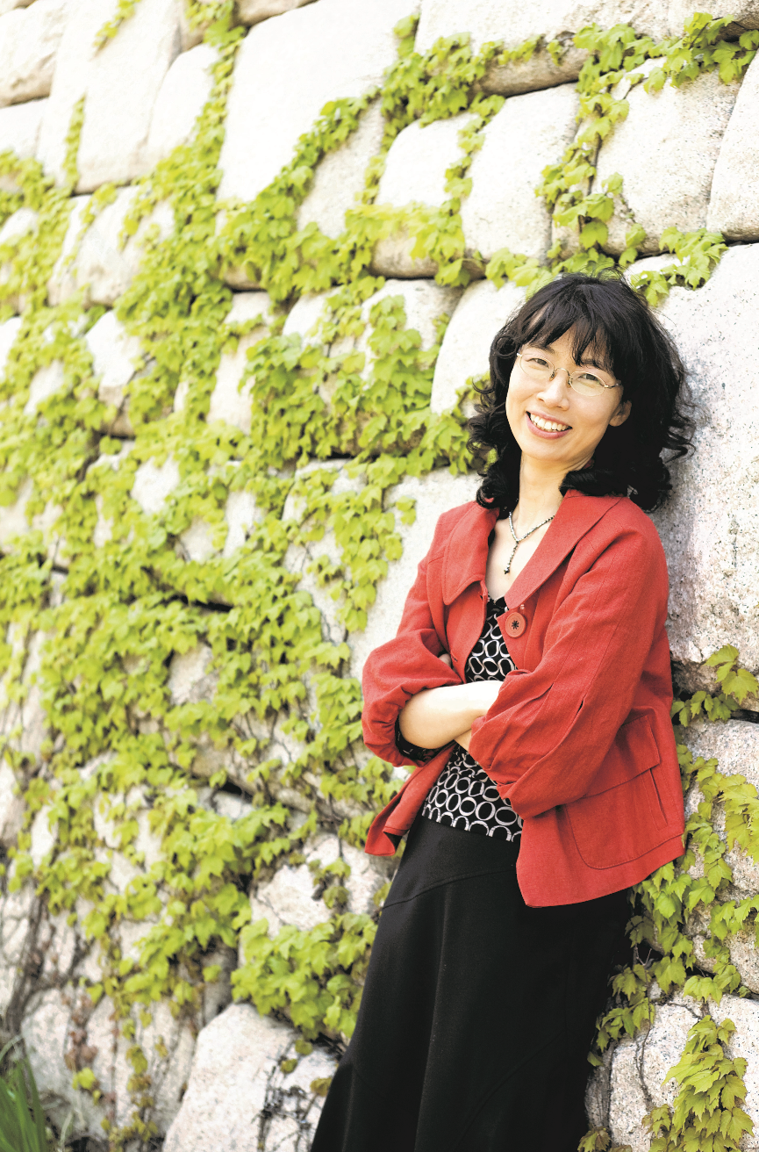

Keutbyul Jeong was born in Naju City, Jeollanam-do Province in 1964, studied Korean Literature at Ewha University, and completed her MA and Ph.D. at the same university. She made her debut in 1988 when her “Sea of Calais” and six other poems were selected for the poetry section of the magazine Munhak Sasang’s annual contest for discovering new literary talents. After her literary critique was selected for the newspaper Dong-A Ilbo’s spring literary contest in 1994, she has been active as a literary critic as well as a poet. She is a professor in the Department of Korean Language and Literature at Ewha University, and also an awardee of the Yusim Literature Prize(2004), the Sowol Poetry Award(2008) and the Cheongma Literature Prize(2015).
As a poet whose characteristic and colorful poetry is developed with poetic feelings full of rhythms and images, she is recognized also as a poet of love who contemplates the world and seeks the intimacy of beings. She has published several collections of poems including My Life, a Birch Tree (1996), A White Book (2000), An Old Man's Vitality (2005), Suddenly (2008) and EunNeunEeGa (2014), as well as her collections of critical writing such as The Poetics of Parody (1997), The Language of Poetry has a Thousand Tongues (2008), The Song of Ooruk (2002), The Poetics of Pi (2010), The Direct Communications between Poetry and Mind (2011), and a number of her essayistic Korean poetic anthologies including In Anyone's Heart, Wouldn't a Poem Bloom? (2008).

In between the possibility of a mother tongue and the impossibility of its translation
Jeong, Keutbyul (poet, critic, professor at Ewha Woman’s University)

My name, “끝별,” is a pure hangul name. Its English transcription reads “Keut-byul,” which for non-Koreans is difficult to pronounce and has no meaning. Once, a junior writer suggested the name “Good-bell” as a play on words, but I chose not to use it. For Chinese readers, my translated poems are published under the Chinese name, “标辰 (標辰),” meaning “a star hanging on a tree branch” or “a bright star.” Still, this feels foreign to me as well. Perhaps it was due to my overly Korean name or my rearing in the songful southern Jeolla Province that I became particularly sensitive to the lyrics of my mother tongue and its tribal strokes and patterns. And many people tell me that my poems have a nice natural flow in Korean. So it seems that I was born with both a special love and aesthetic inclination toward my mother tongue.
I am a longtime believer that the heart of poetry reflects our own heart expressed in our native language. Because poetry is a product of one’s native tongue, which is one’s first language, the poetic language starts with a range of meanings and nuances that a speech community shares. What we recognize as the rhythm, beat, and melody of the mother tongue are what constitute our lives and history. The closer a word is to being monosyllabic, the more comprehensive and inclusive its meaning is. By that, I’m referring to words such as “eyes,” “nose,” “mouth,” “food,” and “poop” that are related to the human body and also to some describing the natural and cosmic world such as “water,” “fire,” “snow,” “rain,” “star,” “moon,” “end,” and “sun.” Words like “house,” “money,” “law,” “work,” and “sweat” are societal, while words like “word,” “letter,” “dream,” “life,” “truth,” and “power” are humanistic. These are simple words in our mother tongue, but they have a texture that is deeper and more complex than we imagine. The reason must be that they are soaked with the idiosyncratic traditions of life, dream, and custom of the speakers, our ancestors.
The poetic heart and one’s mother tongue share the same fate. Given that the relation between a signifier and signified in a language is arbitrarily determined and that a native language is in itself a dialect of a specific tribe, deciphering the meaning of a poem and translating it become an impossible task. Poems could never be perfectly deciphered, interpreted, and translated. Nevertheless, that is all the more reason why the poetic heart must originate from a poet’s mother tongue and its links and breakages. Some words carry meanings, depths, and nuances that only a certain community of people can understand. This is because the tune created when poetic words connect with each other represents the rhythm, beat, and melody of a people’s native language as well as their lives and history. Poetry, in that sense, is comparable to a type of sheet music that turns the internal melody within our bodies into words. In the case of my poem, “Warak,” only native Korean speakers would wholly understand the strokes, patterns, nuances, and significance of the word “와락 (warak, suddenly).” If this word naturally leads a reader to think about other words such as “나락 (narak, bottomless pit),” “벼락 (byeorak, lightning),” and “한 자락 (han jarak, a skirt),” forming a series of meanings, then that is both an untranslatable blessing and limit of one’s mother tongue.
Daniel Tammet, after whom the movie Rain Man starring Dustin Hoffman was made, was an autistic savant with a special talent for numbers and language. He experienced the world through the lens of numbers, and each number came to him like a concrete object with a color, form, texture, and sound. On Pi Day 2014 at 1:59 PM, Tammet shocked the world by reciting the infinite number Pi (3.14159265358979…) to the 22,514th decimal point from memory over the period of five hours and nine minutes. He said that he was able to memorize the Pi because the never-ending sequence of ten Arabic numerals from 1 to 0 was like a sheet music, a story, and a painting to him. The genius was also linguistically gifted; he was fluent in more than ten languages including his native language English and other acquired languages such as French, German, and Spanish. He also created an artificial language called Mänti. Moreover, it only took him about one week to learn a new language. I always wondered about how he perceived the world spatially through numbers and language.
Recently, my desire to understand the concept of spatial perception through one’s native language led me to write a serial poem that plays with different rhymes and anagrams. It was as if I could feel the color, pattern, and texture of each Korean character and phoneme. The waves of sound and meanings contained in a phoneme would continually sweep over me, and sometimes a word would unravel itself to reveal other words that I did not know were there. I discovered certain patterns when fourteen Korean consonants and ten vowels combined and interlocked. What is be the texture of the phoneme “ㅁ (m)” when it comes at the end of a word? What meanings can be drawn from words with the same texture? For example, the words “파란 (paran, blue)” and “나팔 (napal, trumpet)” have the same phonemes. By rearranging the same phonemes, you can come up with two totally different words. I realized that words secretly contain other words that have a completely new sound and meaning.
Some argue that poetry dwells in the untranslatable black space of what is left unsaid, while others say that the meaning, which is very translatable, is what matters. My belief is that the blank space that is untranslated and could never be translated represents the depth of our mother tongue. Nonetheless, I do believe that there are meanings that transcend linguistic barriers and are shared across communities thanks to people’s universal experience and imagination that fill the untranslatable void. Actually, the fact that a poem is in a different and foreign language can make it more refreshing and attractive to some readers. But that is entirely dependent on the ability of the translator and readers from a different linguistic background.
When discussing translation, we often come across the concept of faithfulness. Is faithfulness translating every single word correctly? Or, is it being true to the meanings the poet intended? For the latter scenario, performing transcreation or taking some liberty becomes unavoidable. I was able to find answers to these questions in the words of Bertolt Brecht: “The reason why a poem can become damaged in the process of translation is because people try to translate too much… If an author wrote by arranging words in an unprecedented and unique way, one does not need to translate the writing as is but rather imitate and carry over the thoughts and basic linguistic attitude of the original author.”
Poetry, by nature, is a form of writing that bravely strives toward the impossible. While most forms of literature are like that to a degree, poetry is especially challenging because the ultimate purpose of poetry is not to describe an object or a world but to express its inexpressibility. That is the essence of poetry from which translation must break free.

Love Strategy

Just as you‘re about to cut me down I slash you nick of time
which is known as one strike
The principle that a shared root threads the branches with leaves
is known as one constant

Fearlessly giving myself to you like a fruit and the feeling
of receiving you is one stroke
Without the soil no roots, without the roots, no branches or leaves
this head to tail is one constant, if there’s no me without you

Your look that goes through me is one stroke
My look that comprehends you is a constant

When stroke one lets consistency bloom
breath dashes and surges, winds swell
Soldier is like that, lover is like that

Life’s vital point
I could’ve heard a shriek passing through you

Only love that struck a blow
Perhaps I read the long silence exposing the wind
The first embrace that read me seemed past

I won’t call it a poem’s shrewd strategy

사랑의 병법

네가 나를 베려는 순간 내가 너를 베는 궁극의 타이밍을 일격(一擊)이라 하고
뿌리가 같고 가지 잎새가 하나로 꿰는 이치를 일관(一貫)이라 한다

한 점 두려움 없이 열매처럼 나를 주고 너를 받는 기미가 일격이고
흙 없이 뿌리 없듯 뿌리 없이 가지 잎새 없고 너 없이 나 없는 그 수미가 일관이라면

너를 관(觀)하여 나를 통(通)하는 한가락이 일격이고
나를 관(觀)하여 너를 통(通)하는 한마음이 일관이다

일격이 일관을 꽃피울 때
단숨이 솟고 바람이 부푼다
무인이 그렇고 애인이 그렇다

일생을 건 일순의 급소
너를 통과하는 외마디를 들은 것도 같다

단숨에 내리친 단 한 번의 사랑
나를 읽어버린 첫 포옹이 지나간 것도 같다
바람을 베낀 긴 침묵을 읽은 것도 같다

굳이 시의 병법이라 말하지 않겠다

One More Step

The last bit of weight that brings the camel to its knees
The final axe blow that fells a giant tree

The last glance that chills a love
The extreme breath with which lives end

Looking again looking again until you can’t see
Repeating the work until it runs out

One step closer
One more step until we’re trapped

The hairline crack that empties a dam
General! Last call

One drop of blood that signs off an era
Last sentence that ends a story

If you’d known it couldn’t be repeated
but it had to be repeated, though you knew

One step closer
One more step because you don’t know

한 걸음 더

낙타를 무릎 꿇게 하는 마지막 한 짐
거목을 쓰러뜨리는 마지막 한 도끼

사랑을 식게 하는 마지막 한 눈빛
허구한 목숨을 거둬가는 마지막 한 숨

끝내 안 보일 때까지 본 일 또 보고
끝을 볼 때까지 한 일 또 하고

거기까지 한 걸음 더
몰리니까 한 걸음 더

댐을 무너뜨리는 마지막 한 줄의 금
장군!을 부르는 마지막 한 수

시대를 마감하는 마지막 한 방울의 피
이야기를 끝내는 마지막 한 문장

알았다면 다시 할 수 없는 일
알았다 해도 다시 할 수밖에 없는 일

거기까지 한 걸음 더
모르니까 한 걸음 더

Spine of the World

Someone touches my heart
Someone touches me with money
Someone touches me on the lips
Someone touches me with her shoulder

Touching, that is,
to lift you to a higher place
blindly thrusting me up
to stroke your branch tips that shudder on the unclaimed
empty mountain
I wake roots buried alone in the ground
sit to wait for you with my belly unbound

Like letting water reach the rice paddy
letting tears reach the wound
letting the foundation reach the bottomless
Having reaped and sown all my life
let it be a holy feast
for an open mouth that is instead
of saying I love you

세상의 등뼈

누군가는 내게 품을 대주고
누군가는 내게 돈을 대주고
누군가는 내게 입술을 대주고
누군가는 내게 어깨를 대주고

대준다는 것, 그것은
무작정 내 전부를 들이밀며
무주공산 떨고 있는 너의 가지 끝을 어루만져
더 높은 곳으로 너를 올려준다는 것
혈혈단신 땅에 묻힌 너의 뿌리 끝을 일깨우며
배를 대고 내려앉아 너를 기다려준다는 것

논에 물을 대주듯
상처에 눈물을 대주듯
끝모를 바닥에 밑을 대주듯
한생을 뿌리고 거두어
벌린 입에
거룩한 밥이 되어준다는 것, 그것은

사랑한다는 말 대신

The Foot

My feet bare, people spread nettles beneath those blistered feet
hooting whistling

Dance, sing, flaunt your long night!

In the spring you and I blossomed but not for each other I
couldn't be your song and you left grumbling to find wine and virtue

We weren’t plentiful in the fall

The footsteps that came close were heavy or gross, the footsteps gone
were scattered or faint

Hey, dance, kick up your white feet! All summer the feet reeked of pee
tears All winter the feet wept frozen red

Probably shed tears as they stood against gravity

When the two feet showed wing motion no dance, I saw the hell
of gravity beneath them And originally there were
no two feet

Can’t blame them Can’t blame the weeping feet not wanting to whimper alone
As usual they were opted illusions and their price

The bottom line, the whole sum of tears

발

내가 맨발이었을 때 사람들은 내 부르튼 발아래 쐐기풀을 깔아놓고 손가락 휘슬을 불며 외쳤다

춤을 춰, 노랠 불러, 네 긴 밤을 보여줘!

봄엔 너도 피었고 나도 피었으나 서로에게 열리지 않았다 나는 너의 춤과 노래가 되지 못했고 너는 투덜대며 술과 공을 찾아 떠났다

가을에도 우리는 쌓이지 않았다

가까이 온 발자국은 너무 크거나 무거웠으며 멀리 간 발자국은 흐리거나 금세 흩어졌다

헤이, 춤을 춰, 네 흰 발을 보여줘! 여름내 우는 발은 지린 눈물 냄새를 피웠고 겨우내 우는 발은 빨갛게 얼음이 박혔다

중력에 맞서면서부터 눈물을 흘렸으리라

두 발이 춤 아닌 날갯짓을 했을 때 보았을까 발아래가 인력의 나락이었고 애초에 두 발이 없었다는 걸

너를 탓할 수 없다 따로 울지 않으려 늘 우는 발을 탓할 수도 없다 대개가 착시였고 대가였다

바닥의 총합이 눈물의 총량이었다

When a Branch Crosses the Wall

So to speak, when the weeping willow branches cross the wall
it must not be the willow branches task alone
Innocent branches that have never touched face to face
flowers and leaves that shrug off hands after moment of fleshing together
if they didn’t believe in one mind and one body
these branches would tremble alone endlessly

Without the stubborn five day rain
without the incredible blizzard that piled up eros all night long
crossing the wall, let’s say
would not excite the branches
to set their minds for that moment more than another
If it were not the forbidden wall
enclosing the outside
crossing the wall’s body climbing over its head
dangling willow branches couldn’t dream
the possible opening of the wall

That’s why the branches of magnolia or persimmon
the vines of climbing roses or ivy

when they go over a wall, to the branches
the wall must have been a fellow gambler and an accomplice
that drew the line across original defilement

가지가 담을 넘을 때

이를테면 수양의 늘어진 가지가 담을 넘을 때
그건 수양 가지만의 일은 아니었을 것이다
얼굴 한번 못 마주친 애먼 뿌리와
잠시 살 붙였다 적막히 손을 터는 꽃과 잎이
혼연일체 믿어주지 않았다면
가지 혼자서는 한없이 떨기만 했을 것이다

한 닷새 내리고 내리던 고집 센 비가 아니었으면
밤새 정분만 쌓던 도리 없는 폭설이 아니었으면
담을 넘는다는 게
가지에게는 그리 신명 나는 일이 아니었을 것이다
무엇보다 가지의 마음을 머뭇 세우고
담 밖을 가둬두는
저 금단의 담이 아니었더라면
담의 몸을 가로지르고 담의 정수리를 타 넘어
담을 열 수 있다는 걸
수양의 늘어진 가지는 꿈도 꾸지 못했을 것이다

그러니까 목련 가지라든가 감나무 가지라든가
줄장미 줄기라든가 담쟁이 줄기라든가

가지가 담을 넘을 때 가지에게 담은
무명에 획을 긋는
도박이자 도반이었을 것이다

Sea of Calais

In 1347 English troops occupied Calais. Edward III demanded, if they wanted to save the citizens’ lives, six men come with the city’s key to be executed.

1

I’m a snail in the night
Shall I be the moon or a star?
Laundry rots in a corner
It was May when I first met the sea
Children were rolling in the sweetbriar
on the beach at Calais the sea woke shouting
grew in my heart
May at Calais the sea grew in my heart
I went to meet the sea each night that May

2

Disheartening progress
the first man barefoot holding the city’s key on a rope round his neck
the second man angry hands trembling
the third man bright I must go pulling his friends
the fourth man in faltering decision hangs his head
thinking of his wife and daughter the fifth man
steps firmly the sixth man

3

Let’s go we must go through the wind Let’s go
yelling at the top of our lungs and the slingshot
Though hurling oil soaked cotton balls in flames
cries or stones or oil bottles
they only pile up before the guns and shields
imprisoning us; again at dawn
neighbors carrying coiled ropes take off

4

Citizens grab your weapons
when and wherever you go
when they talk of peace reconciliation forgiveness
in fact they mean conspiracy collusion
desperate ideal
for the real but here as usual
each fearful night
the rope coils tight around my chest

5

Calais is where sweetbriar and mackerel abound
The ocean in May is a mackerel world
Cut open the ocean flesh each year
The whiff of mackerel from my two hands
Isn’t it the sunlight
that wakes the fog wet field?
Isn’t the sweetbriar burrowing
my sandy heart? Don’t know
Calais’s wild roses flowering blood

6

Swoosh … Calais’s beach
surged in salty tang
At night darkness falls here
the herrings still young in fishy scent
Shall I be a flower a bird?
In my room’s corners waste paper mills like a school
of herring
Standing on the verge of the Sea of Calais
out by the sea in May
as the horizon looms up to my chest

칼레의 바다

1347년 영국 군대가 칼레를 점령했다 영국왕 에드워드
3세는 칼레 시민의 목숨을 구하려면, 여섯명의 시민이
시의 열쇠를 가지고 와 사형을 받을 것을 요구했다

1
나는 밤이면 달팽이,
달이 될까 별이 될까
쑤물쑤물 방 한구석에서 빨래감이 썩어가고
내가 처음 바다를 만난 것은 오월이었고
아이들이 해당화와 함께 뒹굴던
칼레의 해변, 바다가 함성을 지르고 일어나
내 가슴속에서 자라고 있었다
칼레의 오월, 내 가슴속에 자라던 바다
나는 그 오월 매일밤 바다를 만나러 갔다

2
우울한 전진,
목에 밧줄을 걸고 시의 열쇠를 든 맨발의 제1인이
두 손을 부르르 떨며 분노하는 제2인이
가야만 한다, 동지를 이끄는 빛나는 제3인이
아직도 결심할 수 없는 제4인이 너무 빠르게
아내와 딸 생각에 머리를 파묻고 제5인이
확고한 걸음걸이로 제6인이 걷는다,

3
가자, 바람 속을 가야만 한다, 가자,
목이 터져라 소리를 지르고 돌팔매
기름 먹인 솜에 불을 붙여 던지기도 하지만
어떤 외침도 돌도 기름병도
우리를 가두는 총과 방패 앞에
수북히 쌓일 뿐, 다시 새벽이면
새끼 몇 발을 꼬아들고 떠나는 이웃들

4
시민이여, 무기를 들라,
그때 그리고 그때마다
화해와 용서로 평화를 말했을 때
실은 야합과 기회를 말한 것이었다
필사적으로 이상적으로
현실을 위해서라고, 그러나 여긴 여전히
무서운 밤 밤마다 또아리를 틀고
내 가슴을 묶는 밧줄이

5
해당화, 청어가 많이 나는 칼레,
오월 바다는 청어들의 세상
해마다 바다의 생살을 째고
두 손에 묻어나는 청어의 비린내
그게 참, 안개 젖은 풀밭을 깨우는
햇빛은 아니었을까
내 모래 가슴을 파고드는
해당화는 아니었을까, 몰라
칼레의 해당화는 피처럼 피고

6
솨솨솨 칼레의 바다가,
짭짜름한 소금기로 밀려왔다
밤이면 심한 어둠이 내리는, 여기의
청어는 아직 작고 비릿하지만
꽃이 될까 새가 될까
청어떼처럼 破紙들이 밀려다니는 웃목
칼레 바다의 길목에 서서
나는 바다 밖에 있었다
수평선이 가슴까지 덮쳐오는 오월에
*Translated by Clare You

